**Entity list:**

1. Phenotype: A clinical condition or characteristic identified and defined based on specific criteria from literature and study protocols.
2. Coding_system: The system or nomenclature used to classify and encode medical information, such as ICD, SNOMED, or RxNorm.
3. Code: A standardized numerical or alphanumeric value assigned to a phenotype, used for classification within coding systems.

**General rule:**

**Examples in red font should be avoided; examples in blue font should be included.**

1. Exclude articles

Example: ~~The~~ International Classification of Diseases

1. Only annotate sentences containing specific codes or coding systems. Sentences are separated by commas.
2. Article type: OS + RCT

**Specific rule:**

**NER:**

**coding system:**

1. For ATC, omit 'classification system' (e.g., Anatomical Therapeutic Chemical (ATC)).

Example: Anatomical Therapeutic Chemical (ATC) classification system

1. Include all coding systems based on semantics, regardless of local or international status.
2. Annotate editions separated by a character as one entity

Example: International Classification of Diseases, Ninth Revision

1. Exclude modifiers before a coding system

Example: ~~specific~~ ICD10CM ~~code~~

ATC~~‐code~~

1. Annotate continuous entities together

example: International Classification of Diseases, Ninth Revision ( ICD‐9 or ICD‐10 )

1. Exclude words following coding system names like 'code', 'classification', 'vocabulary', 'terminology', 'system', etc.

Example: CPT ~~codes~~

**phenotype:**

1. Only annotate phenotypes with a relation to a code or coding system.
2. Start annotation from prepositions (e.g., as, of, with, for, and, like) and commas.

Example:  ~~presence of provider-entered discrete comorbidity of~~ ESKD

~~defined as a composite of~~ fatal bleeding

1. Phenotype definitions include but not limited to lab tests, treatments, procedures, drugs, and problems.
2. Include general names for sets of conditions

Example: existing metastasis (PMC6819452)

PMC6322753

1. annotate complete noun phrase

Example: and hepatitis C virus status was determined u

**code:**

1. Annotate code ranges together

Example: ~~codes~~ 401–404

1. Annotate inseparable codes together

Example: schizophrenia, schizoaffective or delusional disorders (F20,22,23,25,28,29)

**RE:**

**Relation list:**

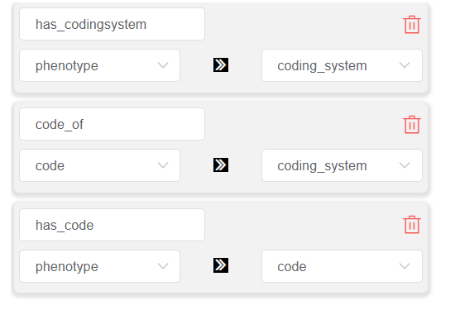

**Phenotype:**

1. For codes or coding systems related to multiple phenotypes (same meaning), annotate only the nearest one (by token count). If equidistant, annotate the first one.
2. When a subtype or specific phenotype is mentioned in the same sentence as a general phenotype, annotate only the subtype or specific name.

**Coding system:**

For codes or phenotypes related to multiple coding systems (same meaning), annotate only the nearest one (by token count). If equidistant, annotate the previous one.